CIS 200 Lab 6 W16

I hate the cover pages by Bruce Elenbogen

Use Case and Class Diagrams

2014 Fall CIS200 – Lab 3

Release date: Sept 22, 2014

Due date: Oct. 2, 2014

Student Name: Bruce Elenbogen

**Question 1.**

Construct a Use Case Diagram of Customer on the basis of the following specification:

Three Actors: Customer, ATM and Bank

Four Use Cases:

(1) Deposit money: invoked by Customer and handled by either ATM or Bank

(2) Withdraw money: invoked by Customer and handled by either ATM or Bank

(3) Notify transaction: invoked by ATM and received by Bank

(4) Repair machine: invoked by Bank to repair a problem on ATM

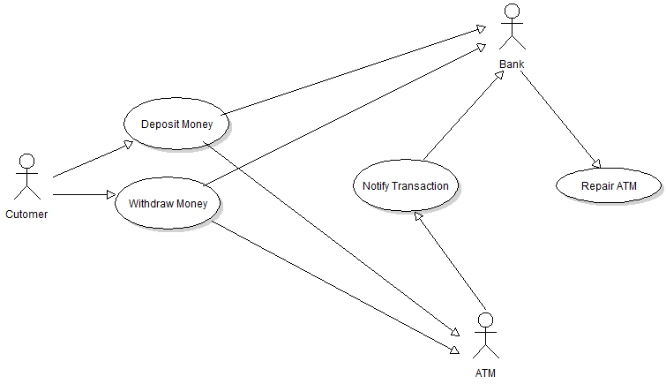

**Question 4.**

Construct a Class Diagram of Employee on the basis of the following specification:

Three Classes: Employee, Fulltime Staff and Part-time Staff

**Class Employee:**

**Attributes:**

Name: String

Address: String

ID#: String

SSN: String

**Actions:**

reportTax() 🡪 Takes no parameters

**End Class Employee**

**Class Fulltime Staff:**

**Attributes:**

Annual salary: float

Health plan: string

**Actions:**

selectBenefit() 🡪 Takes no parameters

**End Class Fulltime Staff**

**Class Part-time Staff:**

**Attributes:**

HourlyRate: float

Weekly hours: int

**Actions:**

fillReport() 🡪 Takes no parameters

**End Class Part-time Staff**

The relationship among these three classes is that Class Employee is the generalization of Class Fulltime Staff and Class Part-time Staff. .

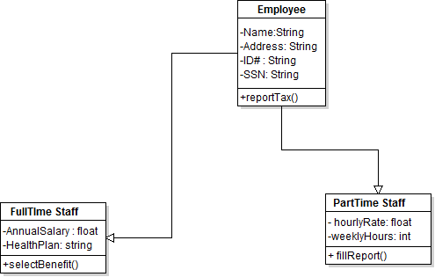

**UML Software**: You may use Microsoft Visio to draw the requested diagrams, and then paste them into a MS word document. If you use hand to draw the diagrams, make sure that you paste the scanned images into the word document. Otherwise, there will be a point deduction.